SIMATS ENGINEERING

NAME:D.SANJANA
REG NO:192471029
COURSE NAME: Database Management Systems
COURSE CODE: CSA0501

AIM
To demonstrate the use of UPDATE and DELETE commands with constraints in the PetAdoptionDB database, ensuring data integrity while modifying and removing records.

PROCEDURE
- Open MySQL Workbench and connect to the MySQL server.
- Select the database PetAdoptionDB using the USE command.
- Use the UPDATE command to modify existing records in tables such as Pets and Adopters.
  - Constraints like CHECK, UNIQUE, and FOREIGN KEY ensure that updates follow rules (e.g., Age must be positive, Email must remain unique).
- Use the DELETE command to remove records from tables.
  - Constraints such as FOREIGN KEY prevent deletion of parent records if child records exist.
- Execute the SQL statements and verify results using SELECT.

OUTPUT:
UPDATE:
-- Update adopter’s phone number
UPDATE Adopters
SET Phone = '9001234567'
WHERE AdopterID = 2;

-- Change adopter’s email (UNIQUE constraint ensures no duplicates)
UPDATE Adopters
SET Email = 'rahul.new@example.com'
WHERE FullName = 'Rahul Mehta';
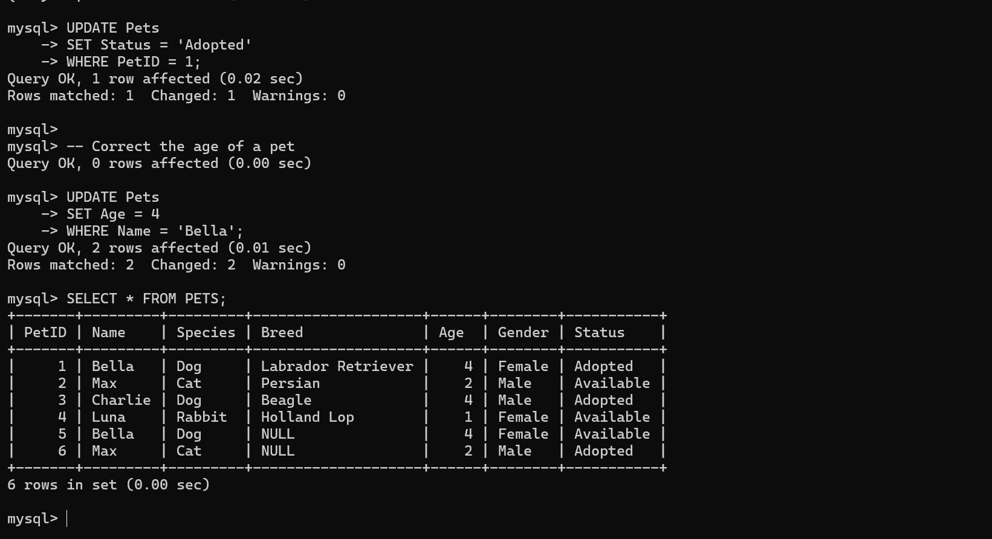

DELETE:

-- Delete an adopter by name
DELETE FROM Adopters
WHERE FullName = 'Alice Johnson';

-- Delete adopters living in Bangalore
DELETE FROM Adopters
WHERE Address LIKE '%Bangalore%';
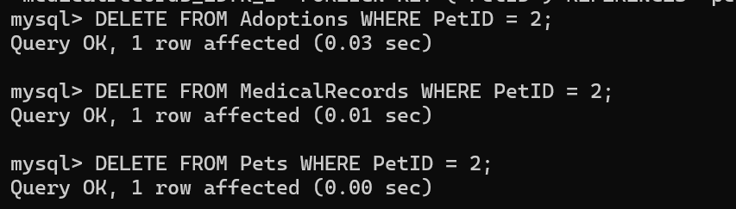

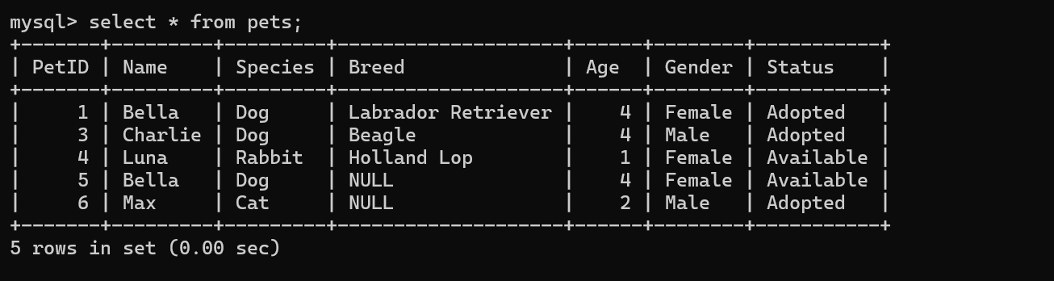

RESULT:
Data Manipulation Language (DML) Commands such as UPDATE, DELETE are performed in the five tables.

